**ASSIGNMENT 1 [For OBE Assessment]**

**Instructions:**

1. Attach the assignment document [which was uploaded in VUES account] as top 2 pages of the whole assignment.
2. Assignment should be Handwritten.
3. After that, scan it using suitable mobile scanner (cam scanner, adobe scanner etc.) and make it as pdf file.
4. Rename the pdf file name with your ID.
5. Copied/identical submissions will be graded as 0.

**The deadline to submit this assignment is 08 April 2021 (Thursday) until 10:00 pm. Please prepare your assignment and submit it in Microsoft teams within this deadline.** The submission procedure is mentioned below

Submission Guidelines:

1. **Click on the view assignment** in Microsoft teams as shown below. You will get it in our class in Microsoft teams.

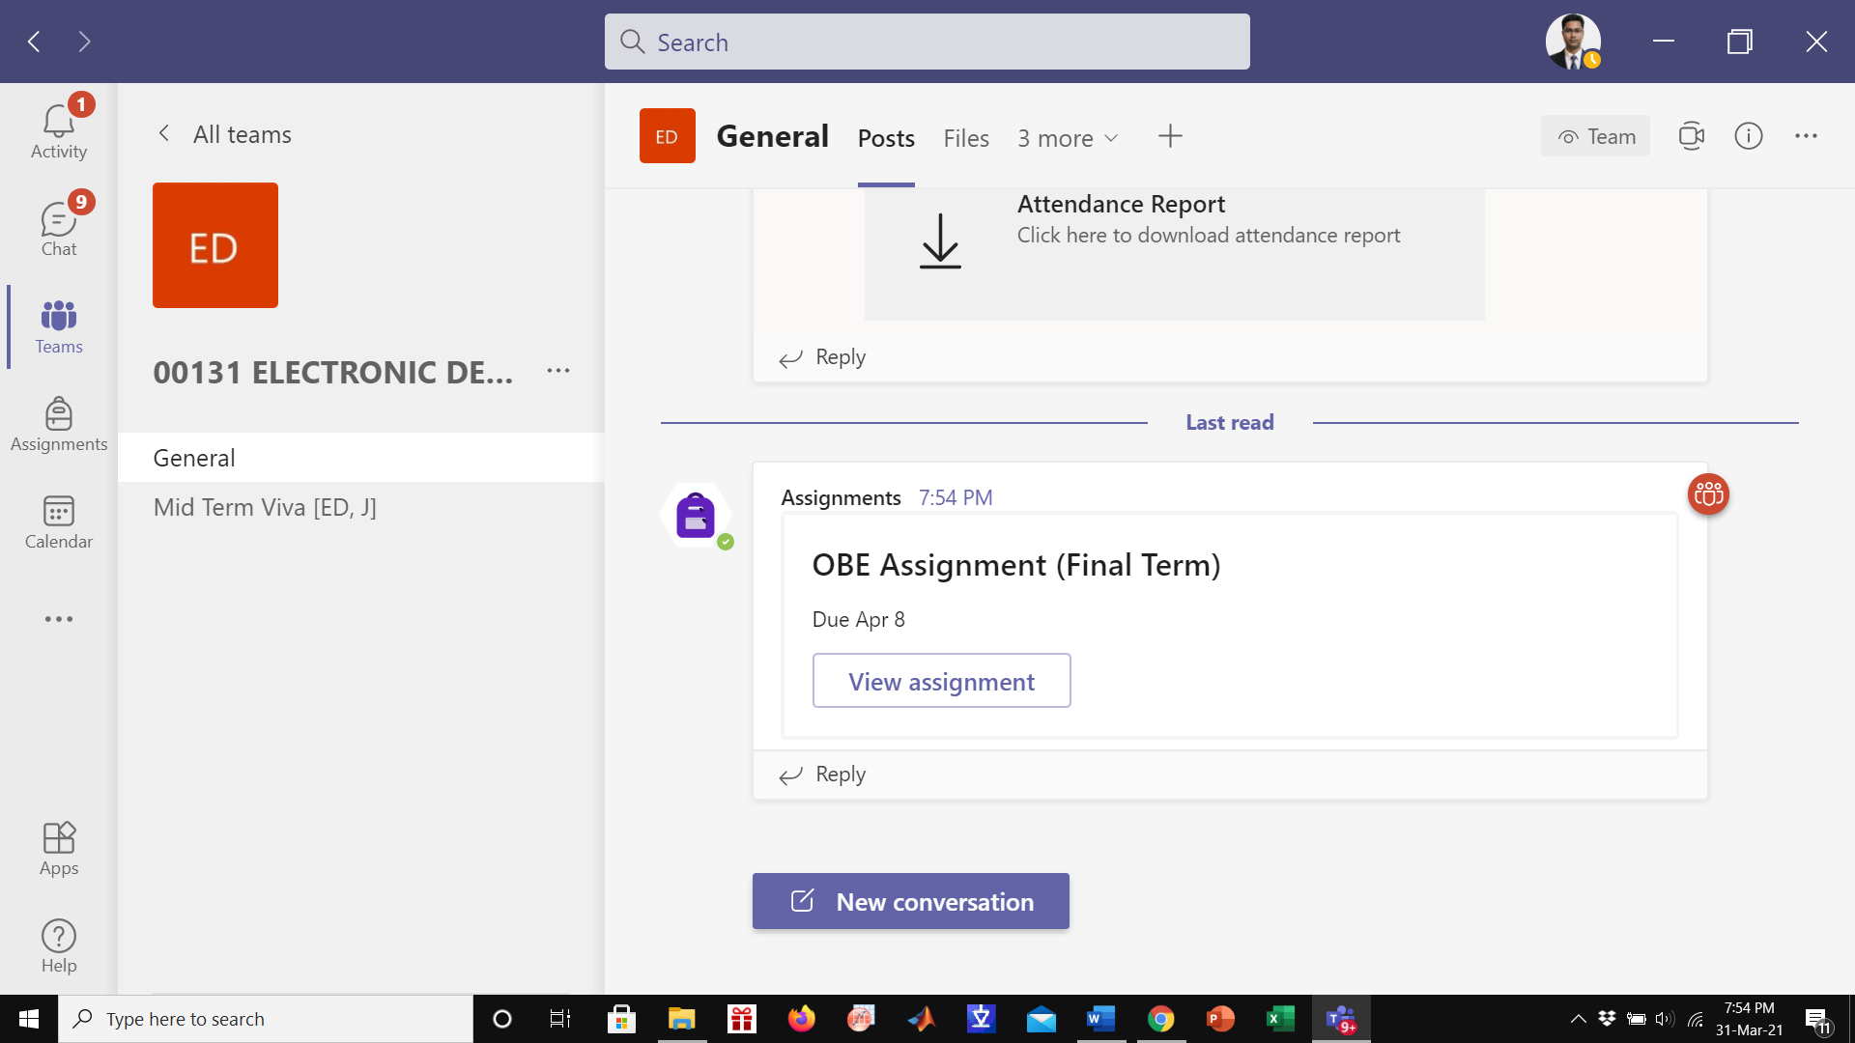

1. After that, click on the **Add work.** Here you can upload your assignment.
2. After upload, click on the **turn in option (laptop view**) or click **Hand In option (mobile view).**

With best regards,

Dr. Rifat